Meet Author JENNIFER NIELSEN!
On Thursday, September 21st, New York Times Bestselling author Jennifer Nielsen will be visiting our School! She is the author of The Ascendance trilogy, the MARK OF THE THIEF series, The Scourge, and A Night Divided. You can learn more about the author and her work at jennielsen.com. If you would like signed and personalized books, please return this form to the library with payment by Friday, September 15th. Prices reflect a 10% discount, plus tax.

Quantity |  | Title | Cost | Total
Personalized to: |  | Deadzone: Horizon Book 2 (NEW!)  The survivors have made it out of the jungle, but they may be sorry they ever left when they stumble upon a whole new ecosystem, populated with entirely new threats.  And the greatest threat of all may come from within. Because one of the kids is changing... | $14.70  Hardcover book
Personalized to: | 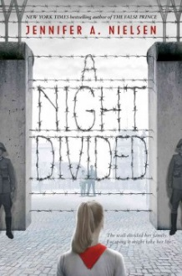 | A Night Divided  Eight-year-old Gerta awakens one morning to a fence cleaving her family in two—her father and one of her brothers were on a trip to West Berlin while the rest of the family became trapped in the East. Four years later, the Berlin Wall has become a harsh reality, but a secret message from her father, hidden in a silly dance, gives Gerta hope and a plan for escape: tunneling to freedom. | $16.70  Hardcover book
Personalized to: | 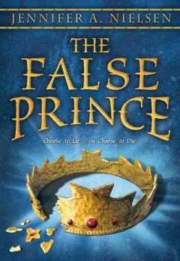 | The False Prince  In this first book in a remarkable trilogy, an orphan is forced into a twisted game with deadly stakes. In a discontent kingdom, civil war is brewing. To unify the divided people, a nobleman of the court devises a cunning plan to find an impersonator of the king's long-lost son and install him as a puppet prince. Four orphans are recruited to compete for the role, including a defiant boy named Sage. | $7.85  Paperback book
 |  | Horizon Book 1 by Scott Westerfeld  When a plane crash-lands in the arctic, eight young survivors emerge from the wreckage expecting to see ice and snow but instead find themselves lost in a strange jungle with limited supplies and fierce predators. | $14.70  Hardcover book
Thank You! | ORDERS DUE in your library by Friday,  Sept. 15th. | Cash or Check (payable to The Book Stall) enclosed | Total:

Student’s Name: ________________________ Teacher: _______________________

